##### BC/YK Open Synchronized Skating Championships

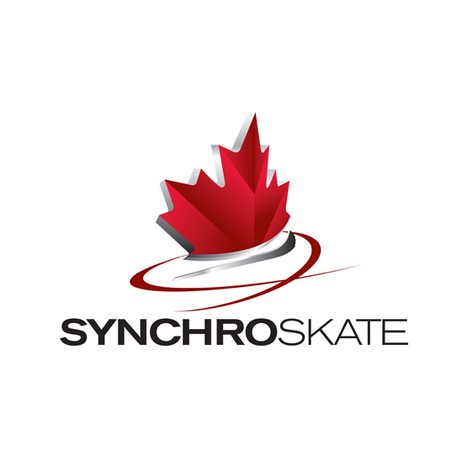

##### TEAM ENTRY FORMS *

Please read and complete this package carefully. Please print clearly.

|  |
| --- |
| CATEGORY *(check ✓)*  Beginner I  Beginner II  Elementary  Juvenile  Pre-Novice  Novice  Intermediate  Open  Junior  Senior Adult SYS Class I  Adult SYS Class II  Adult SYS Class III  TEAM NAME:  CLUB: CLUB #: SECTION:  TEAM MANAGER:  ***(Surname)******(First name)***    ***(Street)***    ***(City) (Province/State) (Postal Code)***  🕿( ) FAX #: ( )  E-mail:  TEAM COACH:  ***(Surname)******(First name)***    ***(Street)***    ***(City) (Province/State) (Postal Code)***  🕿( ) FAX #: ( )  E-mail:  TOTAL NUMBER OF TEAM MEMBERS CHOREOGRAPHER:  DESCRIPTION OF TEAM COSTUMES  SHORT PROGRAM:    FREE PROGRAM:  **Registration forms should be returned NO LATER THAN DECEMBER 2, 2014 to**  **BC/YK Section**  **#2 – 6501 Sprott Street, Burnaby, BC, V5B 3B8**  **Email:** [**bcyksection@skatinginbc.com**](bcyksection@skatinginbc.com) |
| **Entry fee: $250.00 per team plus $30.00 per skater, Cheques payable to BC/YK Section - Skate Canada** |



##### BC/YK Open Synchronized Skating Championships ACCREDITATION FORM

##### *(PLEASE PRINT CLEARLY)*

TEAM NAME:

CATEGORY *(check ✓)*

Beginner I  Beginner II  Elementary

Juvenile  Pre-Novice  Novice

Intermediate  Open  Junior

Senior Adult SYS Class I  Adult SYS Class II

Adult SYS Class III

|  |  |  |  |  |  |
| --- | --- | --- | --- | --- | --- |
|  | NAME | Date of Birth (d/m/y) | Place of Birth | Skate Canada/USFSA Registration # |  |
| 1. |  |  |  |  |  |
| 2. |  |  |  |  |  |
| 3. |  |  |  |  |  |
| 4. |  |  |  |  |  |
| 5. |  |  |  |  |  |
| 6. |  |  |  |  |  |
| 7. |  |  |  |  |  |
| 8. |  |  |  |  |  |
| 9. |  |  |  |  |  |
| 10. |  |  |  |  |  |
| 11. |  |  |  |  |  |
| 12. |  |  |  |  |  |
| 13. |  |  |  |  |  |
| 14. |  |  |  |  |  |
| 15. |  |  |  |  |  |
| 16. |  |  |  |  |  |
| 17. |  |  |  |  |  |
| 18. |  |  |  |  |  |
| 19. |  |  |  |  |  |
| 20. |  |  |  |  |  |
|  |  |  |  |  |  |
|  |  |  |  |  |  |
|  |  |  |  |  |  |
|  |  |  |  |  |  |

|  |  |  |  |
| --- | --- | --- | --- |
| FUNCTION | Name | | Skate Canada/USFSA Registration # |
| Team Coaches (max. 2) |  | NCCP Level: |  |
|  |  | NCCP Level: |  |
| Team Manager |  | | -- |
| Team Chaperones (max. 2) |  | | -- |
|  |  | | -- |

* A maximum of 5 support staff will be accredited.

* Two coaches, one team manager and two chaperones for a total of five people per team will be accredited.

* Team chaperones will be allowed in the dressing rooms ONLY.

DO ALL TEAM MEMBERS MEET THE AGE REQUIREMENTS AS LISTED IN THE EVENT ANNOUNCEMENT? ❑ YES ❑ NO

I confirm that all information included in this registration form is correct and meets the requirements as listed in the event announcement.

________________________ _______________________________ __________________

Coaches Name Signature Date

________________________ _______________________________ __________________

Team Managers Name Signature Date

**PLANNED PROGRAM SHEETS:** Planned program sheets must be emailed to the registrar at [bcyksection@skatinginbc.com](mailto:bcytsection@attglobal.net) BEFORE December 13, 2014.

OFF ICE PRACTICE: Off-ice practice is available at a cost of $40.00 for a 30 minute block. The facility is located across the parking lot from the Arena complex. A separate registration form for this off-ice practice will be sent to all teams once the schedule is finalized.