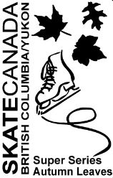
Program Messages
2016 AUTUMN LEAVES

Program Messages Order Form
Name: Click here to enter text.
Address: Click here to enter text.
Phone Number: Click here to enter text.
☐ Simple Acknowledgment (Name Only) (ex. “Go Alex!”) $5.00
☐ Personal Message (8 Words Max) (ex. “Skate Well Amy! Love Mom and Dad”) $10.00
☐ Picture with 5 Words $15.00
Text for Program: Click here to enter text.
Mr. Skate
You are the best Coach!

Please return Order Form by October 12, 2016 to:
Email: courtney@skatinginbc.com
Fax: 604-205-6962
(Please email all pictures)

Credit Card Payment:
Card Type: ☐Visa ☐ Mastercard
Card #: Click here to enter text.
Expiry #: Click here to enter text.

Skate Well Amy!
Love Mom and Dad
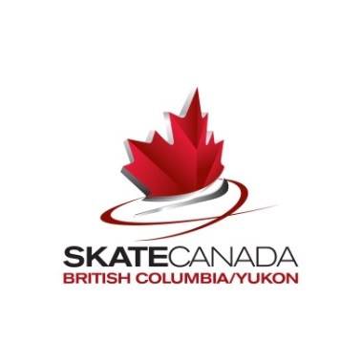
Name on Card: Click here to enter text.

